Web Development – Mr. Turner

Project – The Running Man

**Project Overview**

Using a bank of images, create an animation on screen.

**The Page**

In the folder called Runner, there are 12 images, named “zero” through “eleven” in sequence. Using an array, create a page that goes from image to image, in sequence, and displays the runner running.

Start with the first image on the screen. Place a ***Next*** button beneath the image.

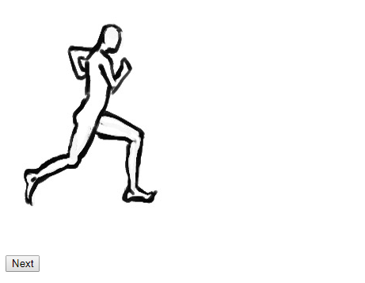

Each time the user clicks on the next button, the image should *change* to the next image in the sequence, making it look as if the runner is running.

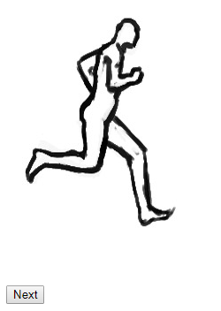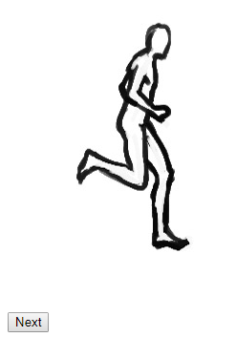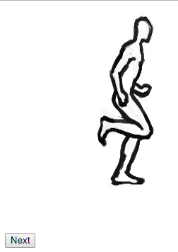

**Bonus**

1. Move the runner across the screen.
   * Each time the sequence reaches its end, move the entire image 300 pixels to the right to simulate the runner actually moving across the screen.
2. When the runner exits the screen on the right, he should come back in on the left side.
   * ***Hint*** – The width of the window can be accessed using window.innerWidth.
3. Instead of relying on the next button, create a timer for the runner.
   * There is a function called setInterval(functionCall, timing) which will automatically call a function again and again on a set interval.
     + The functionCall argument would be a string value that calls a function (like when you call a function in an event).
     + The timing argument is a number that represents the number of miliseconds between calls.

**Programming Requirements**

|  |
| --- |
| * You must code your own HTML and CSS. Use of a drag and drop interface or the usage of code downloaded from the internet is not permitted. |
| * Use of deprecated code is not permitted. Use an HTML 5 reference as your guide. |
| * You must comment your name into the top of every page. |
| * Your code must be structured in a consistent and legible manner |
| * Your text must be organized through the use of sectioning tags (div, span, p, h1 – h6). Tables are acceptable for data but not for page design. |
| * Your interface must be smooth and easy to figure out for a client. |
| * Your pages must be formatted using CSS. |